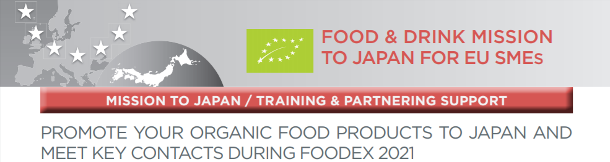

EXPRESSION OF INTEREST
EU Organic Food&Beverage Mission

at Foodex Japan
8-12 March 2021

The EU-Japan Centre is studying the feasibility of organising an “Organic Food” mission to Japan in March 2021 alongside “FOODEX Japan 2021” and is currently calling for “Expressions of Interest” among Enterprise Europe Network partners in order to identify among their clients EU SMEs interested in this opportunity.

If you would like to join the mission, please fill this Expression of Interest form and send by Friday, the 31st of January 2020 to: jessica@eu-japan.eu and Loredana.affinito@cam.camcom.it

Participant’s profiles
This mission is addressed at EU SMEs working in the organic food and drinks sector, who can offer high-quality products with packaging strategies towards Japan.
The SMEs’ products must be certified with the EU organic logo.

Benefits for EU SMES
Through this mission, participants will have the opportunity to:
- Gain knowledge about the targeted market structure, sector analysis, presentation of EU-Japan Economic Partnership Agreement benefits
- Exhibit at FOODEX JAPAN, Asia's largest exhibition dedicated to food and drink
- Create new business opportunities
- Identify relevant key contacts
- Establish first contact and potential business relationships with Japanese companies.

Costs
- No mission fee

The EU-Japan Centre covers mission-related costs such as:
- Trade fair registration
- Booth rental & basic arrangements
- Speakers’ fees, lectures and seminars
- Poster translation and printing
- In addition, SMEs participating in the mission will benefit from 600 EUR grant

Costs covered by the participants
- Travel costs to/from Japan, transfer from/to the airport, accommodation and any other costs not covered directly by the EU-Japan Centre.
- The transfer of food or any additional equipment to the fair will be at participant's cost.
- Participants are required to pay a 1000 EUR refundable deposit to guarantee their place on the mission.
The mission is funded by the European Commission and managed by the EU-Japan Centre.

EXPRESSION OF INTEREST
Agrofood
Sector Group

TRADE MISSION TO JAPAN
for EU Organic Food&Beverage SMEs

at Foodex Japan 2021

1. I express my interest in this European Company Mission to Japan

2. I have read and agree to the above mentioned terms and conditions for this mission.

Title: First Name: Surname:
Company Name: Position:
Address:
Country:______________________________________________________________________
State/province: ________________________________________________________________
City: _________________________________________________________________________
Postcode:
Telephone: Mobile:
(Only the Event Organisers can see your phone numbers)
Fax Email:
Website:
Business Sector:

Date:
COMPANY INFORMATION

VAT Number:
Year Established:
Number of Employees:
Annual Turnover:

Organisation description
Write a short description about what your organisation does.

Areas of Activity *
Areas of Activity help us to categorize what you do and offer.
This makes easier for other participants to find you and makes your profile more expressive.

Please select areas of activity that suits your profile:
Supermarket
- Sweets, chocolates and candies
- Meat
- Seafood
- Pasta
- Rice and Beans
- Cocoa, cocoa powder, cocoa solutions
- Oils, Sauces, Salad Dressings and Condiments
- Cereals and breakfast foods
- Soups and Canned goods
- Frozen foods
- Dairy, Cheese and Eggs
- Biscuits, Cookies, Snacks and Crackers
- Drinks
Gourmet products distributor
- Cheese
- Charcuterie
- Foie Gras
- Baking and pastry
- Chocolates
- Pantry
- Oil and Vinegar
- Spices and condiments
- Truffles and Mushrooms
- Seafood
- Wine Beer Spirits
HORECA (hotels, restaurants and catering)
- Bakery
- Seafood
- Meat
- Poultry
- Potato
- Dairy
- Dry food
- Pasta
- Sauces & Condiments
- Savoury Solutions
- Sweet Solutions
- Desserts
- Still Water
- Sparkling Water
- Beverages Solutions
- Juices

Fresh
- Fruit
- Vegetables
- Frozen food
- Organic
- Healthy

Your offer/request
Add and describe one (or more) product/service/partnership/investment

NEW PRODUCT
Product
Add and describe a product you are offering to your profile

Title(max 160 characters):

Description (make your description clear and appealing):

What are you looking for? Please, select
- Distribution Partner
- Exporter
- Wholesaler
- Importer
- Suppliers
- Other (specify): _________________

Market application keywords
- Food and Beverage
- Gourmet market for food and beverage
- Food and Beverage for HORECA
- Supermarkets
- Fresh food
- Non Alcohool drinks
- DairyBakery
- Wine
- Oil

This event is organised by

